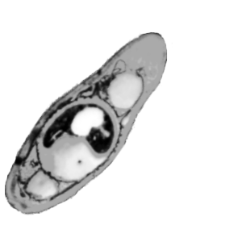

NCAIM

National Collection of Agricultural and NCAIM use
Industrial Microorganisms
1118, Budapest Access. No.:
Somlói út 14-16.
Hungary

Strain Accession form

Data supplied in this form will be recorded in the NCAIM database and cited in the NCAIM Catalogue of strains. Please fill in below and the other side by typewriter or in block letters and give your signature on the other side.

1. Scientific name and author(s):

2. Number or code of the strain:

3. Synonyms/name change:

4. History since isolation (If the strain was not isolated by you, please indicate from whom you received it):
NCAIM Depositor (Strain No. )

5. Other culture collection designations (if deposited):

6. Taxonomic status:
Is this strain the type of the species?
Yes No
7. Recommended medium and growth condition (Please specify formula):
Medium:

Temperature: °C

8. Recommended method for long-term preservation:
freezing freeze-drying other:

(To be continued on the other side)
9. Isolation data:
Isolated by: Ref. ( ) Date:
Substrat/host:
Locality:
Identified by:
10. Is this strain pathogenic?
humanpathogenic zoopathogenic phytopathogenic unknown

It is classified in risk group
1 2
11. Application of the strain (production, assay, education, etc.):

Ref. ( )
12. If the strain is a mutant or has been genetically modified in any other way, please give details:

13. References (Attached reprints will be appreciated):
1.
2.
14. Comments:

I understand that this strain will be considered free for unrestricted distribution unless otherwise requested here:

Date:
Name:
Institution:
Address:
Tel: Fax:
E-mail:
Signature:

